STUDENT NAME: HARINATH.M

REGISTER NO AND NMID: 24bca060 & asunm123212400467

DEPARTMENT: B.C.A Computer application

COLLEGE: Mohamed Sathak College of Arts and Science

# PROJECT TITLE



DIGITAL PORTFOLIO

3

/

2

1

/

2

0

2

4

**A**

**n**

**n**

**u**

**a**

**l**

**R**

**e**

**v**

**i**

**e**

**w**



**AGENDA**

1

.

P

r

o

b

l

em St

at

e

m

e

n

t

2

.

P

r

o

j

ect

O

vervi

e

w

3

.

E

n

d

U

s

er

s

4

.

T

o

o

l

s

and T

e

c

h

n

o

l

o

gi

e

s

5

.

P

o

r

t

f

o

l

i

o

d

e

s

i

gn

an

d

L

ayo

u

t

6

.

F

eat

u

r

es

an

d

F

u

n

c

t

i

o

n

al

i

t

y

7

.

R

es

u

l

t

s

and

S

c

r

e

e

n

s

h

o

t

s

8

.

C

o

n

cl

u

s

i

o

n

9

.

G

i

t

h

u

b

L

i

n

k

**PROBLEM STATEMENT**

In today’s competitive digital world, individuals lack a centralized, professional, and visually appealing platform to showcase their academic achievements, skills, and projects. A digital portfolio is necessary to present personal and professional information effectively.



**PROJECT OVERVIEW**

The Digital Portfolio Website is a personal platform designed to highlight academic, technical, and creative skills.



It contains sections such as About Me, Education, Projects, Skills, Certifications, and Contact information.

The website is responsive, user-friendly, and customizable.

**WHO ARE THE END USERS?**

Students – Showcase academic achievements and skills

Job Seekers – Highlight projects and certifications

Professionals – Build an online personal brand

Recruiters/Employers – View candidate portfolios easily

## TOOLS AND TECHNIQUES

Frontend: HTML, CSS, JavaScript, Bootstrap

Backend: Python (Flask/Django) or PHP (if required)

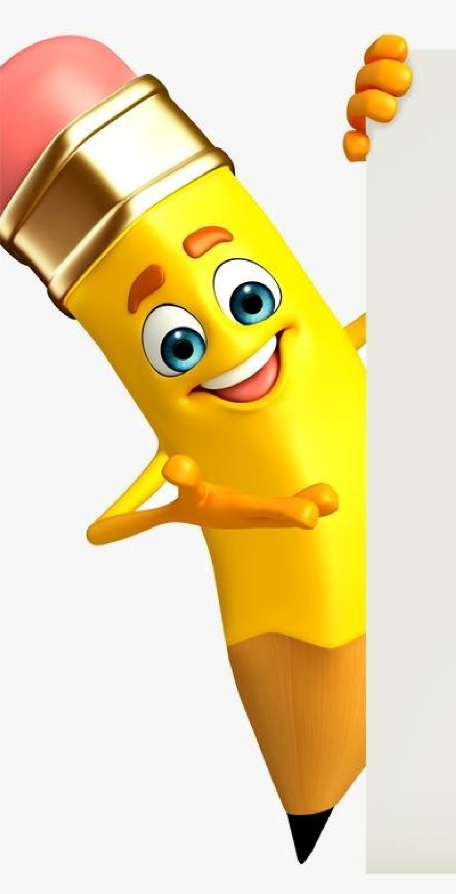

Database: MySQL / SQLite (optional)

Hosting: GitHub Pages / Netlify

Version Control: Git & GitHub

**POTFOLIO DESIGN AND LAYOUT**

8

The design follows a clean, minimal, and professional layout with proper navigation. Sections include: Home, About, Skills, Projects, Education, Certifications, and Contact.

The portfolio is responsive for both desktop and mobile devices.



**FEATURES AND FUNCTIONALITY**

User-friendly interface with smooth navigation

Responsive design for mobile and desktop

Sections for About, Projects, Skills, and Contact

Integration with LinkedIn/GitHub

Downloadable Resume option

# RESULTS AND SCREENSHOTS

1

0

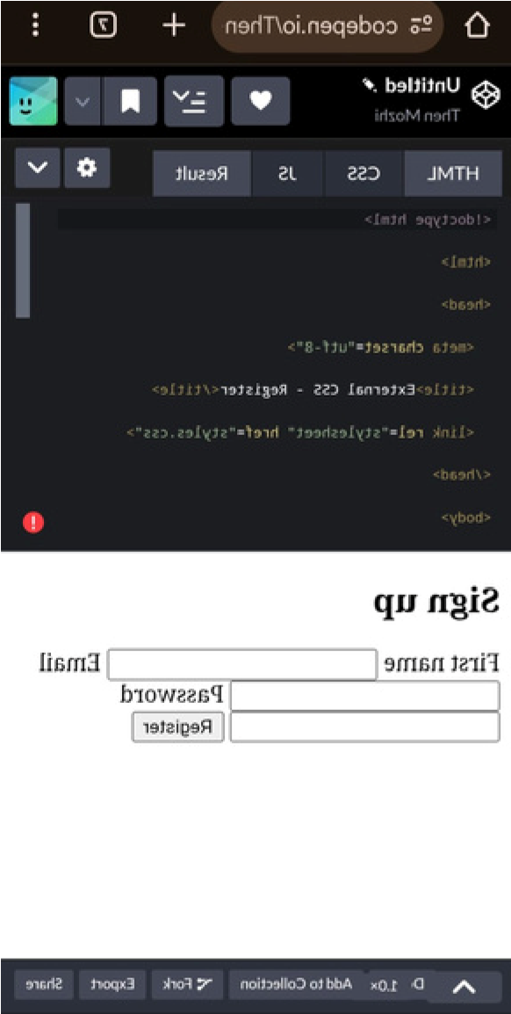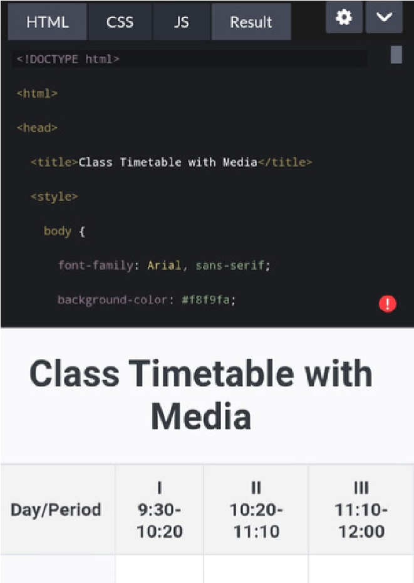

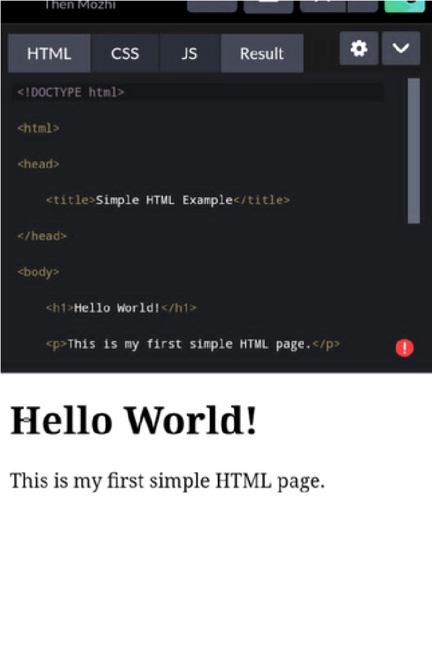

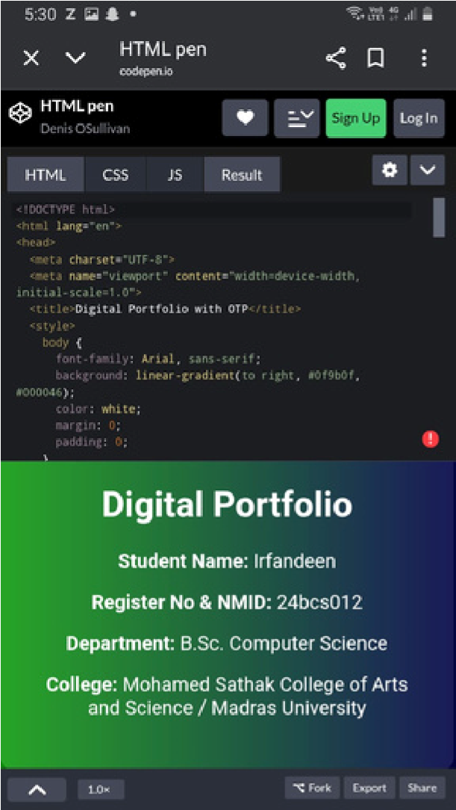

3

/

2

1

/

2

0

2

4

**A**

**n**

**n**

**u**

**a**

**l**

**R**

**e**

**v**

**i**

**e**

**w**



**CONCLUSION**

The Digital Portfolio Website provides an organized and professional way to present personal achievements, skills, and projects.

1

1

It enhances career opportunities and creates a strong digital presence

